DecodeLabs AI Chatbot
Project Documentation
Rule-Based AI Chatbot - IPO Model
Internship Project | DecodeLabs | June 2026
Prepared by Areeb Ahsan

1. Project Overview
This document describes the development process, design decisions, and code modifications made during the DecodeLabs internship project. The goal was to build a Rule-Based AI Chatbot using the IPO (Input-Process-Output) Model in Python.

1.1 Project Goals
- Build a rule-based chatbot that responds to predefined user inputs
- Implement the IPO Model: Input Sanitization → Processing → Output
- Use if-else logic and dictionary-based intent matching
- Run the chatbot in a continuous loop with a clean exit command
- Apply the .get() method for atomic lookup with fallback handling

1.2 Key Skills Demonstrated
- Control flow and decision-making logic
- Python dictionaries, functions, and loops
- Input sanitization and normalization
- Basic AI concepts: discrete vs continuous mapping
- Code documentation and the DRY (Don't Repeat Yourself) principle

2. Architecture - The IPO Model
The chatbot follows a three-stage pipeline inspired by the Hybrid Architecture shown in the DecodeLabs course material:

Stage 1 - Input & Sanitization
Every message the user types is passed through the sanitize() function before anything else happens. This function:
- Converts the entire input to lowercase using .lower()
- Strips leading and trailing whitespace using .strip()
This ensures that "Hello", "HELLO", and "hello" all map to the same key in the knowledge base.

Stage 2 - Processing (The Infinite Loop)
The chatbot runs inside a while True loop, the "infinite organism" that keeps the program alive until a kill command is received. Inside the loop:
- The sanitized input is looked up in the knowledge_base dictionary
- The .get() method handles both the lookup and the fallback in a single atomic operation
- If a match is found, the mapped response is returned
- If no match is found, a default fallback response is returned

Stage 3 - Output (Response Generation)
The matched response is printed to the terminal using an f-string. A newline character (\n) is added after each response for readability.

3. Codebase Walkthrough

3.1 Knowledge Base
The knowledge_base is a Python dictionary where each key is a possible user input (normalized to lowercase) and each value is the bot's response:
knowledge_base = {
"hello": "Hello! I'm DecodeBot. How can I help you today?",
"how are you": "I'm just a bot, but doing great!",
"help": "You can ask me greetings, how I am, or just chat!",
}

3.2 Input Sanitization Function
The sanitize() function is the entry point for all user input:
def sanitize(user_input):
"""Normalize input: lowercase + strip whitespace"""
return user_input.lower().strip()

NOTE: Sanitization is intentionally set to lowercase (.lower()) only, as per the project requirement of the IPO Model. This means all user input (Hi, HI, hI) is auto-converted to lowercase before lookup — eliminating the need for uppercase keys in the knowledge base. If required, uppercase handling could also be added by removing .lower() and manually adding uppercase variations in the knowledge base instead.

3.3 Response Engine (.get() Method)
The get_response() function performs the lookup and fallback in a single atomic operation:
def get_response(user_input):
"""Lookup intent with fallback in single atomic operation"""
clean_input = sanitize(user_input)
return knowledge_base.get(clean_input, "I'm not sure about that.")

The .get() method takes two arguments:
- First argument: the key to look up (clean_input)
- Second argument: the fallback response if the key is not found

3.4 Main Loop (The Infinite Organism)
while True:
user_input = input("You: ")
if sanitize(user_input) in ["quit", "exit", "bye", "goodbye"]:
print("DecodeBot: Goodbye! Have a great day!")
break
response = get_response(user_input)
print(f"DecodeBot: {response}\n")

Key elements:
- while True - runs forever until break is called
- input("You: ") - waits for user to type a message
- Kill command check - if user types quit/exit/bye/goodbye, the loop breaks
- f-string output - cleanly formats the bot's reply

4. Modifications & Design Decisions

4.1 Expanded Knowledge Base
The knowledge base was significantly expanded from the original minimal version to include:
- Greeting variations: hello, hello!, hi, hi!, hey, hey!
- Farewell variations: bye, goodbye, arrivederci
- About the bot: what is your name, who are you, what can you do, what else can you do
- Small talk: how are you, what's up, thank you, thanks, i'm tired, i'm upset
- Help entry for user guidance

4.2 Apostrophe Key Fix
An important discovery was made during testing: keys containing apostrophes (e.g., "I'm tired") must be written in lowercase in the knowledge base because the sanitizer converts input to lowercase before lookup. The fix was:
- Changed "I'm tired" → "im tired" and "i'm tired" (both variants added)
- Changed "I'm upset" → "im upset" and "i'm upset"
- This ensures the chatbot matches regardless of whether the user uses an apostrophe

4.3 DRY Principle - Loop-Based Key Mapping
Instead of repeating the same response string for every variation of a greeting, Python's loop-based dictionary population was introduced as a cleaner approach:
greeting_response = "Hello! I'm DecodeBot. How can I help you today?"
greetings = ["hello", "hello!", "Hello", "Hello!", "HELLO"]
for word in greetings:
knowledge_base[word] = greeting_response

This approach follows the DRY (Don't Repeat Yourself) principle defining the response once and mapping multiple keys to it programmatically.

5. Project Screenshots

5.1 Initial Chatbot Running
The chatbot running successfully in the VS Code terminal with the DecodeBot branding:
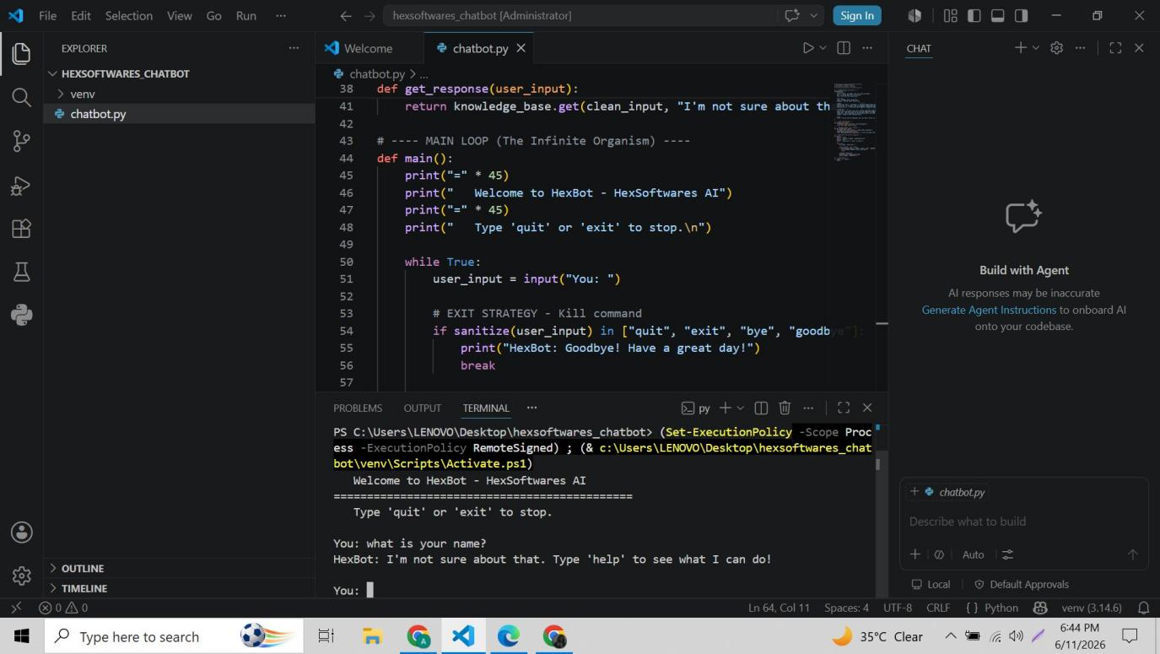
Screenshot: DecodeBot running in VS Code terminal - testing responses

5.2 Final Codebase — Knowledge Base
The complete knowledge base with all intents, greetings, farewells, small talk, and help entries:
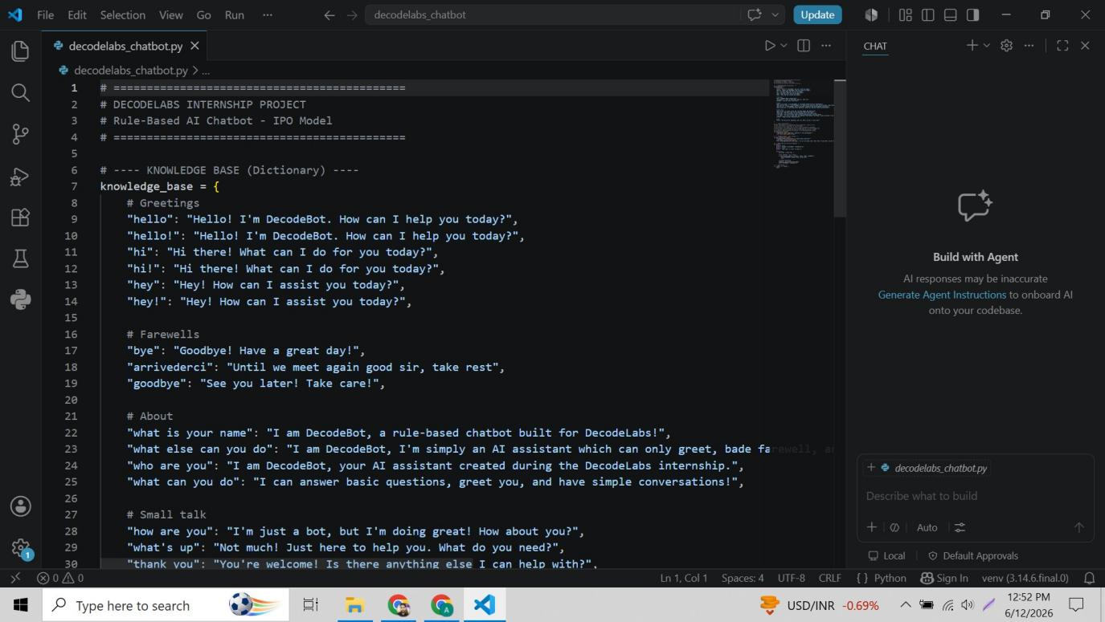
Screenshot: Knowledge base section of decodelabs_chatbot.py

5.3 Final Codebase - Sanitization & Response Engine
The sanitization function with documentation comment, and the response engine using the .get() method:
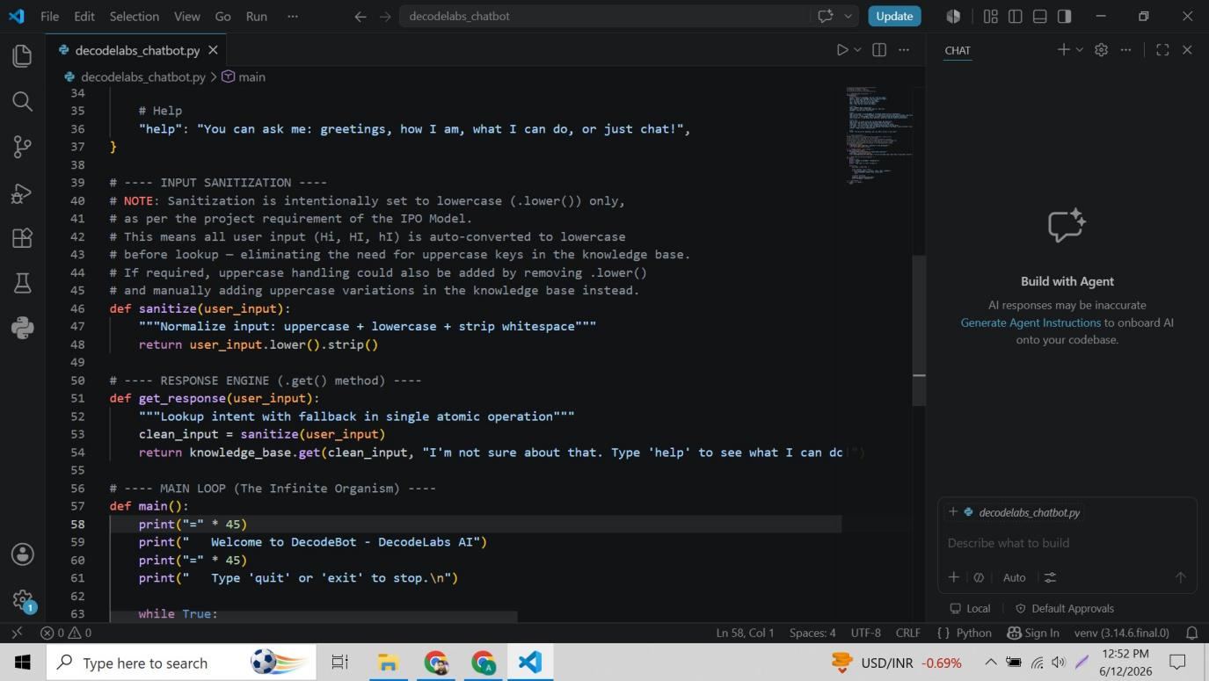
Screenshot: Sanitization note, sanitize() function, and get_response() function

5.4 Final Codebase - Main Loop & Entry Point
The main loop (infinite organism), exit strategy, response generation, and entry point:
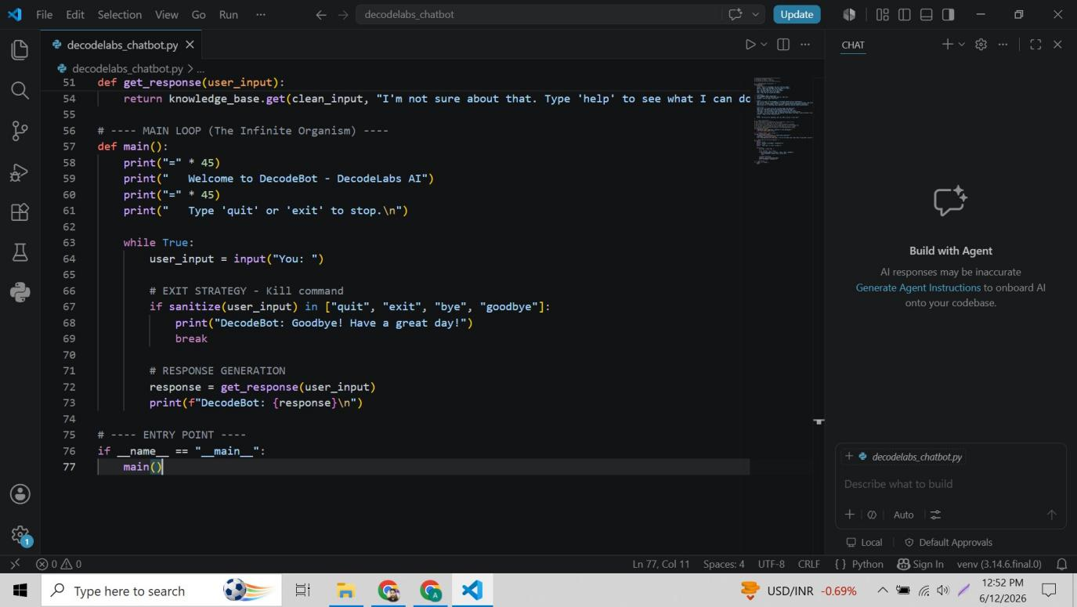
Screenshot: Main loop, kill command, response output, and entry point

6. Key Concepts Explained

6.1 Discrete Mapping vs Continuous Mapping
This chatbot uses Discrete (Exact) Mapping:
- The user's input must exactly match a key in the knowledge base (after sanitization)
- There is no tolerance for typos or synonyms
- This is reliable and fast but requires all variations to be explicitly defined

Continuous (Semantic) Mapping used in LLM-based systems like GPT understands meaning and context, handling variations automatically. This would be the next step in upgrading this chatbot.

6.2 The Hybrid Architecture
The DecodeLabs course material describes a Hybrid Architecture where:
- Rule-based responses handle known intents instantly (speed)
- LLM fallback handles unknown or complex queries (flexibility)
This chatbot implements the rule-based layer. The fallback message ("I'm not sure about that...") represents where an LLM integration would plug in for the full hybrid system.

6.3 Why .lower() in Sanitization
The sanitize() function uses .lower() to normalize all input to lowercase. This means:
- "Hi", "HI", "hI", "hi" all become "hi" before lookup
- The knowledge base only needs lowercase keys
- Uppercase variations in the knowledge base become redundant
If .lower() were removed, every possible capitalization would need its own entry in the knowledge base — making it significantly harder to maintain.

7. How to Run the Project

Prerequisites
- Python 3.8+ installed
- VS Code installed with Python extension
- Virtual environment activated

Steps
1. Open VS Code and navigate to the decodelabs_chatbot folder
2. Open the terminal (Terminal → New Terminal)
3. Activate the virtual environment:
venv\Scripts\activate
4. Run the chatbot:
py decodelabs_chatbot.py
5. Start chatting! Type any of the supported inputs.
6. To exit, type: quit, exit, bye, or goodbye

Supported Inputs
- Greetings: hello, hi, hey (and variations with !, uppercase)
- Farewells: bye, goodbye, arrivederci
- About: what is your name, who are you, what can you do
- Small talk: how are you, what's up, thank you, thanks
- Emotional: im tired, im upset
- Help: help
- Exit: quit, exit

AI rule-based Chatbot GUI:
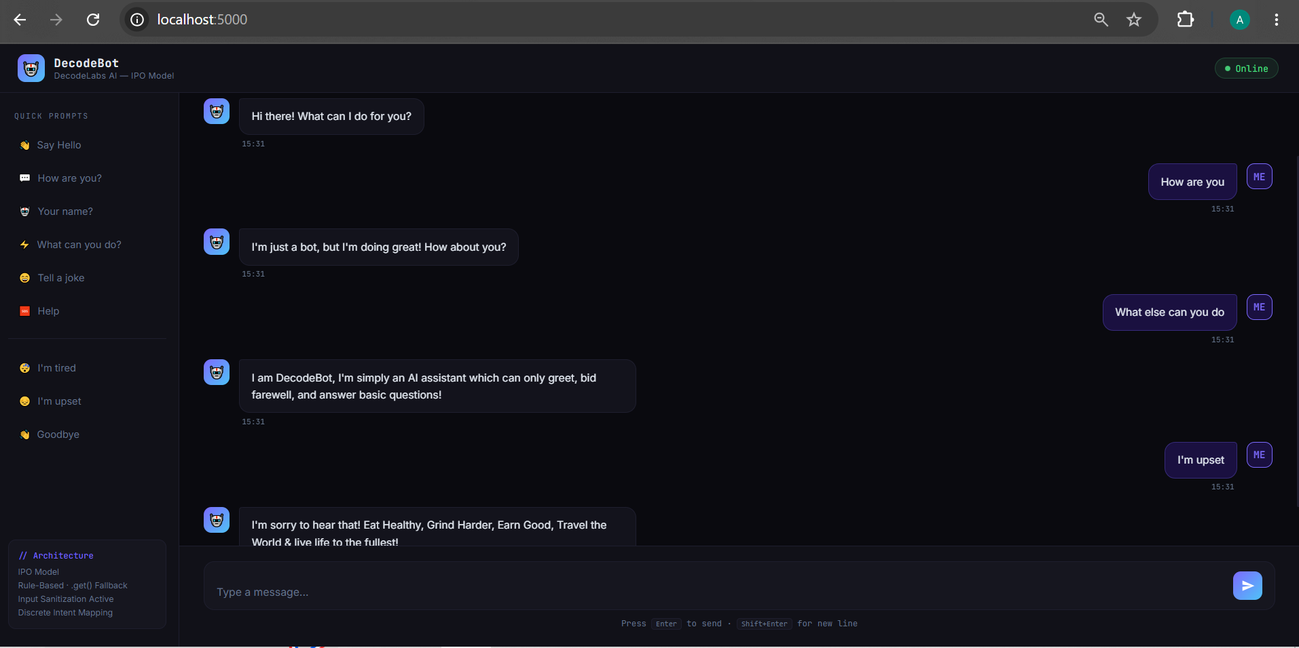
Casual Greetings are performed smoothly as all the knowledge base has all the relevant information regarding it.
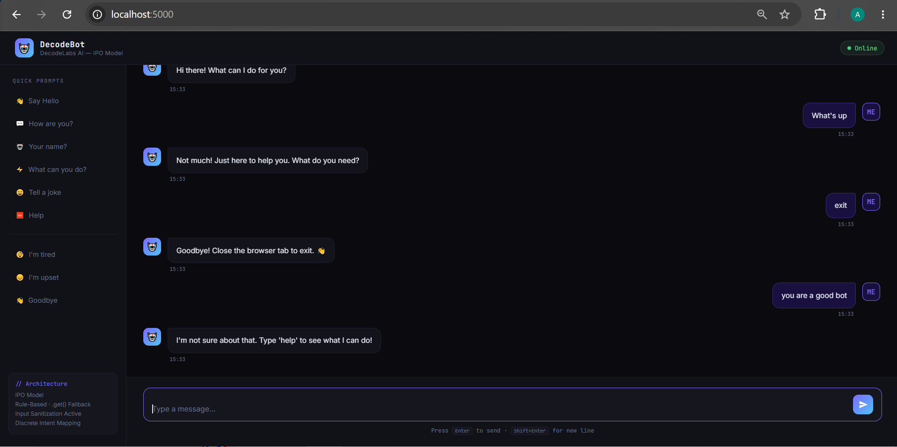
Fallback gracfully onto single atomic operation in the last line of the above mentioned screenshot.
DecodeLabs Internship Project | Rule-Based AI Chatbot | June 2026

